PAR TRACKER
- Purpose:

US Silica PAR Tracker application tracks multiple projects for different customers, their approval workflows for each project. It also maintains documents, attachments for the individual projects.

- VMs:
- QAD/PAR Dev VM:
IP: 10.12.2.36
USER: vm-qad-dev\qaddev
PASS: Q@dParDev!2022
- QAD/PAR Prod VM:
IP: 10.8.1.49
USER: vm-qad-dev\qaddev
PASS: Q@dParDev!2022

- Connecting to VM:
- Connect to USS VPN using GlobalProtect
- Connect to the VM using Remote Desktop Connection

- Running Test PAR App:
  - Connect to USS VPN using GlobalProtect
  - PAR Test app: https://testpar.ussilica.com:8443/
  - PAR Prod app: https://partracker.ussilica.com/users/sign_in

- Code location:
- Repo location: https://bitbucket.org/ussilica/par-tracker/
- Par deployment location: C:\partracker\par-tracker
- Jboss server location (Runtime server): C:\partracker\jruby-9.1.15.0\lib\ruby\gems\shared\gems\torquebox-server-3.2.0-java\jboss

- Attachments:

All the attachments related to the project are stored in:
C:\partracker\par-tracker\public\uploads\attachment

- Deployment:

Deployment is done by adding/ restarting the PAR service
- Open Windows Services
- Select PAR Tracker Application Server from the list
- Click on STOP
- Open command prompt as admin and run torguebox undeploy and then torguebox deploy (If there are any code level changes)
- Then click on START

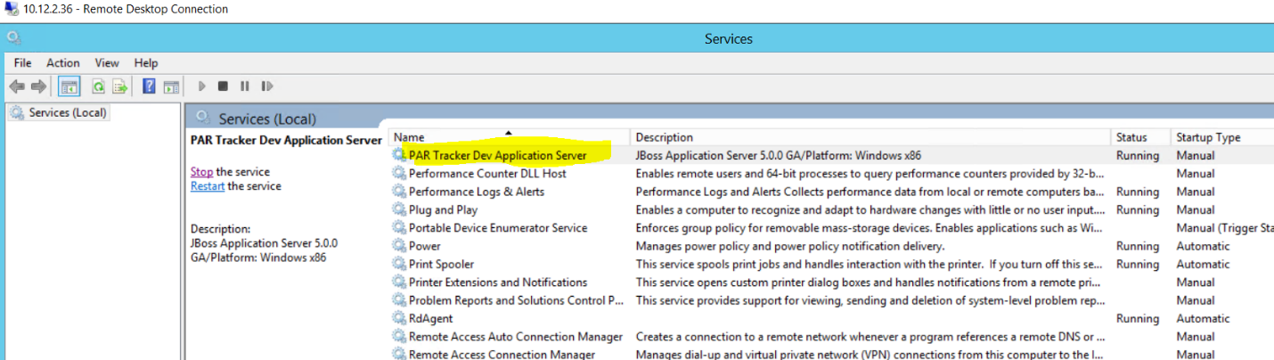

- Logs:

- Log Script location: C:\partracker\log_script
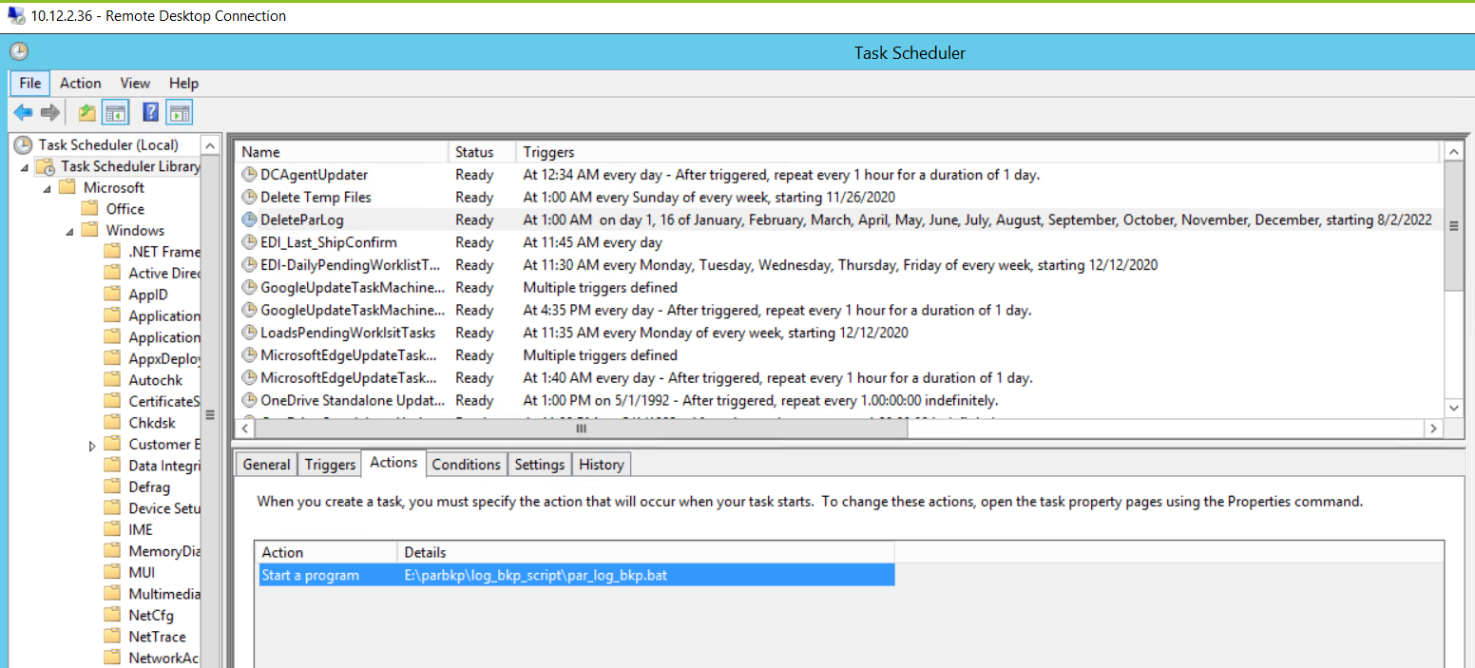
- Task scheduled to Delete Logs on 1st and 16th of every month.
- The deleted logs are saved in: E:\parbkp\log_bkp

- The UI:

- Dashboard: Lists all the project for the user which are pending approval.
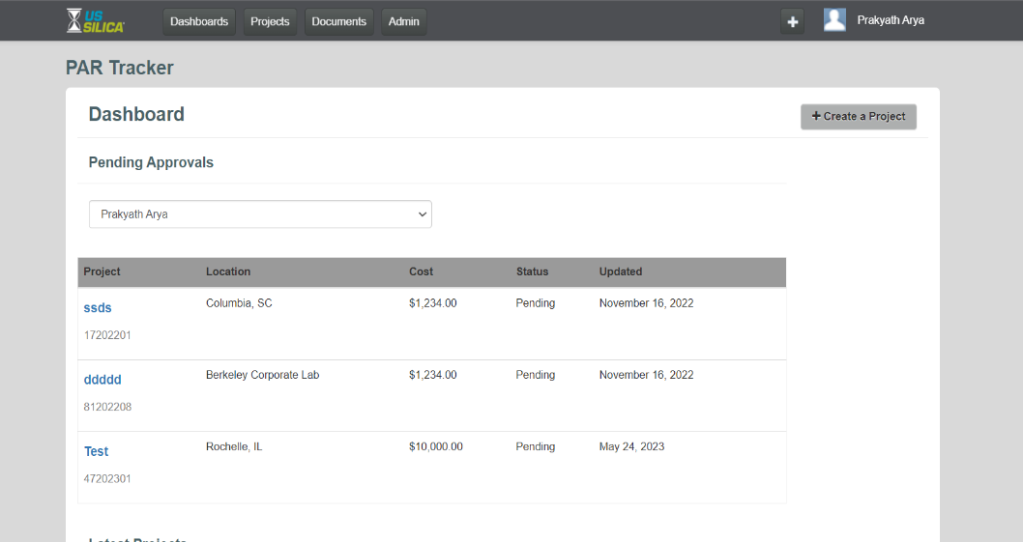
- Project: Lists all the projects.
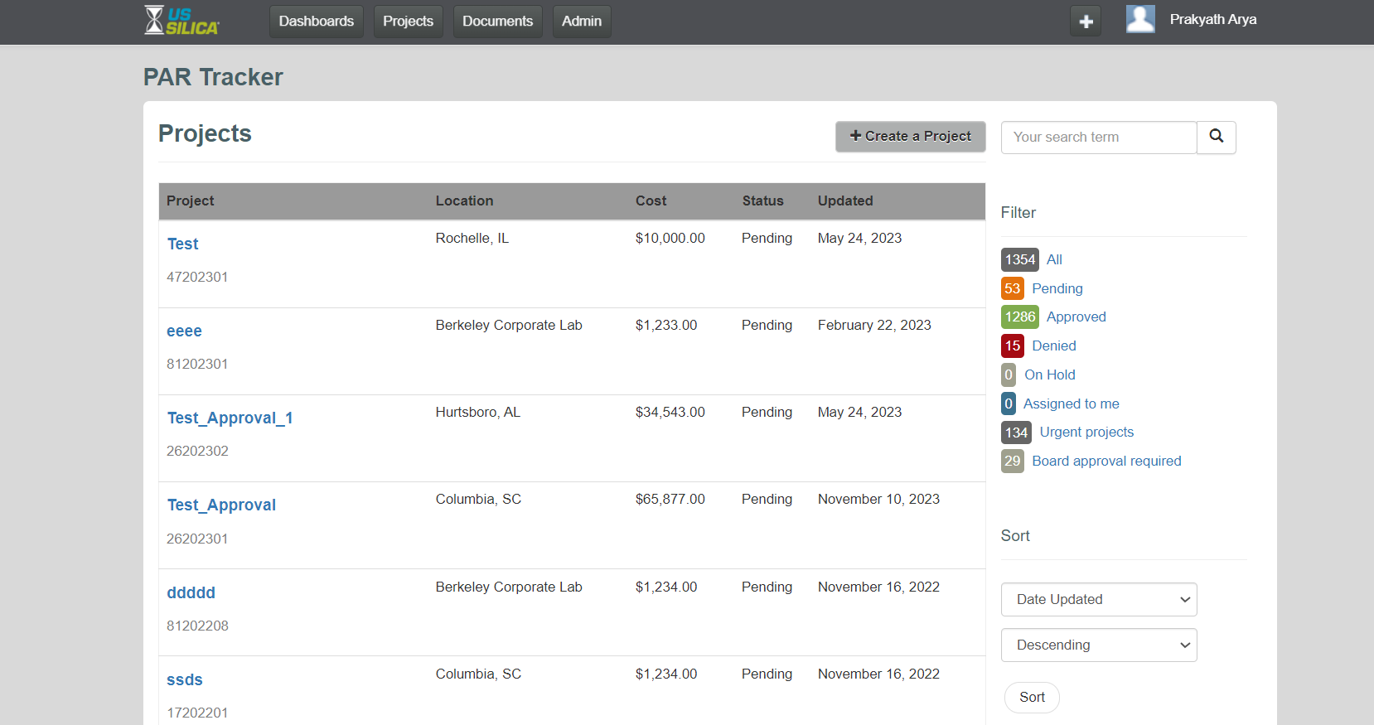
- Create a Project:
Fill in the required project details.
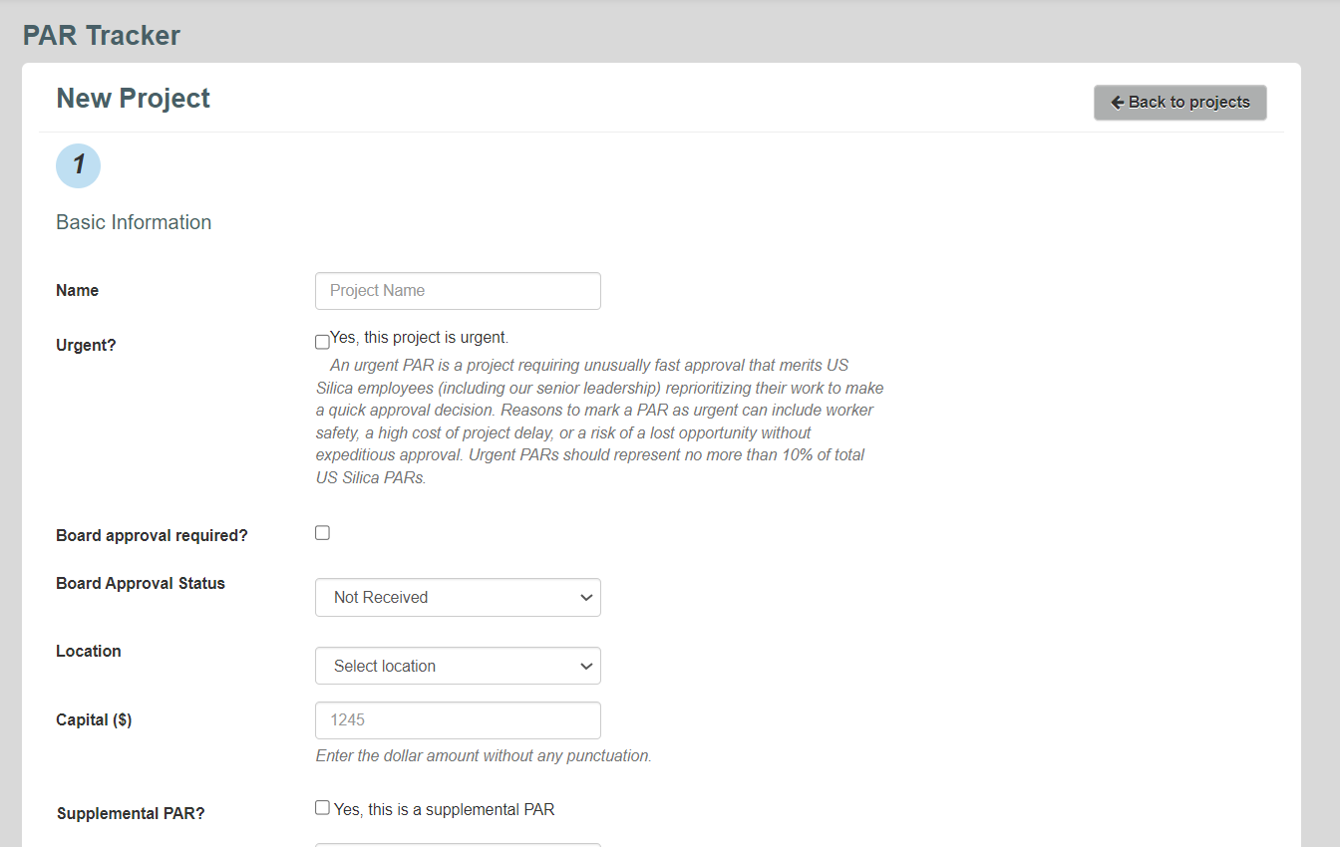
Add the approvers.
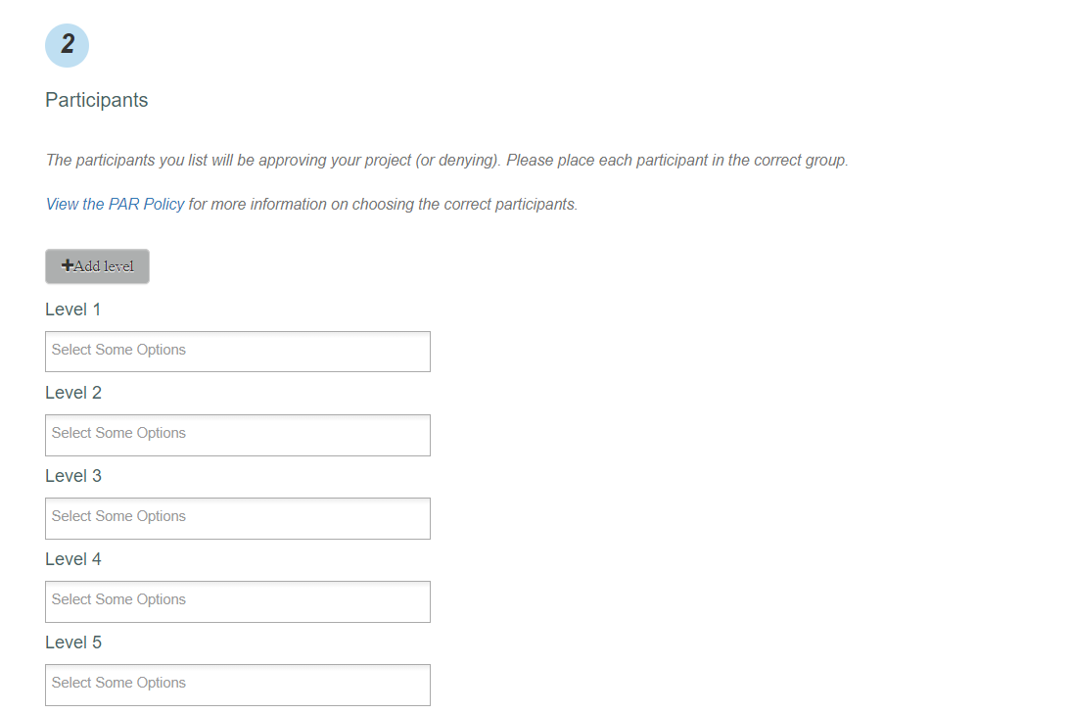
Add attachments if any.
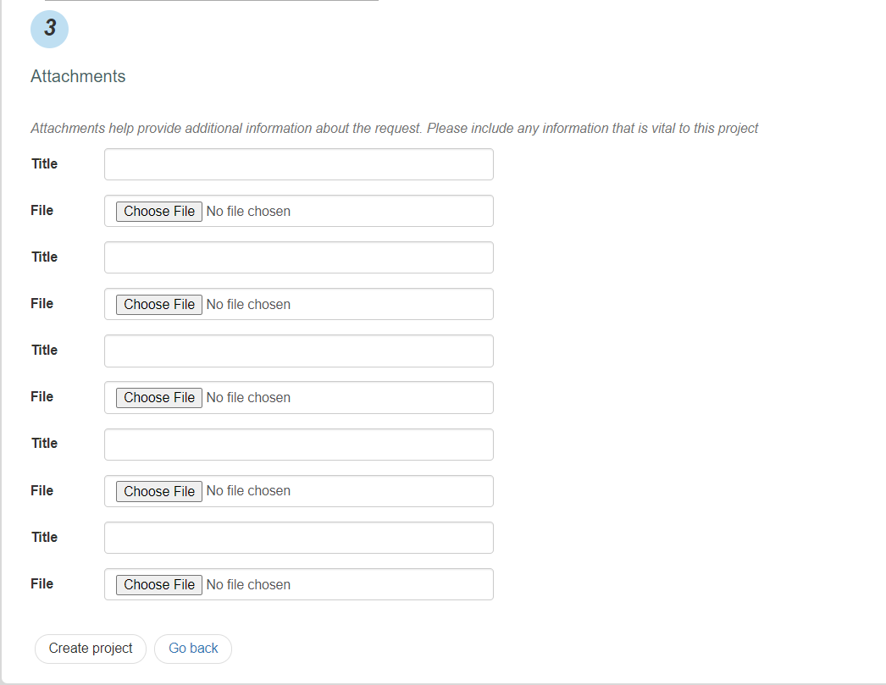
- Admin: Lists all the Users, Locations, Classification and Report.
- Users: Lists all the Users. Create or edit a User.
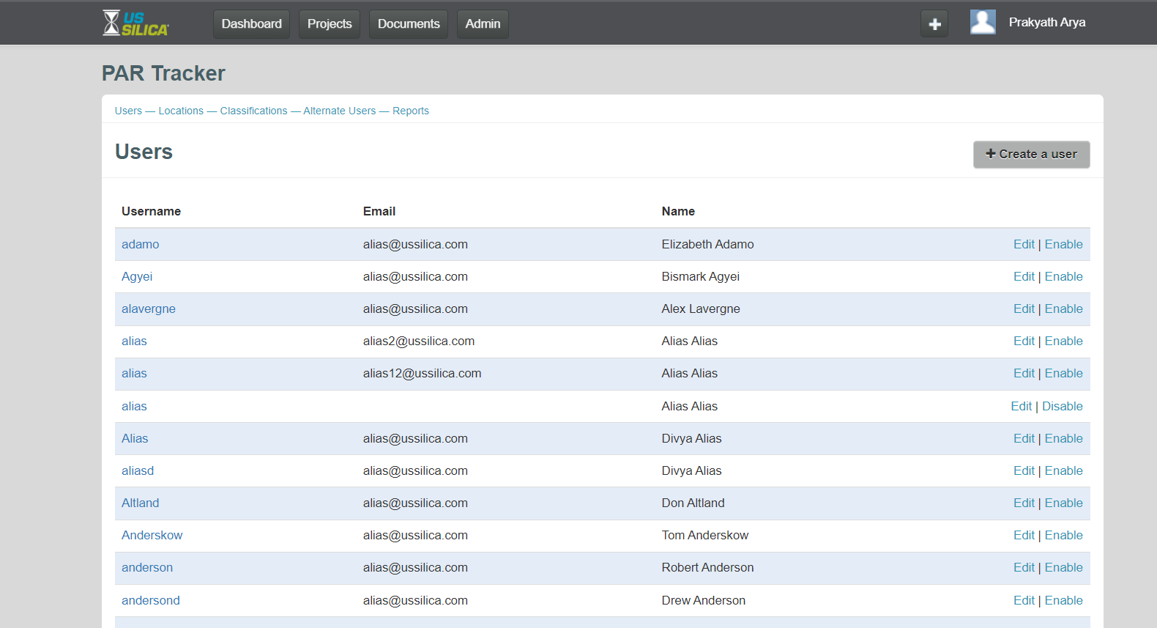
- Create a User:
Enter Username and Email. Tick the fields if the user is to be made an admin. Choose the location for which the user must be added as a default approver or make the user a default approver for all locations.
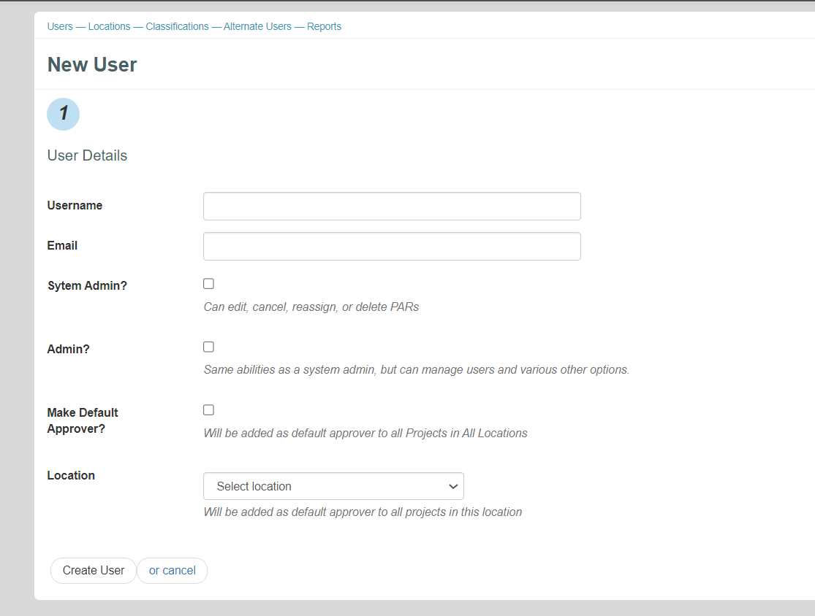
- Locations: Lists all the location. Create or edit a location.
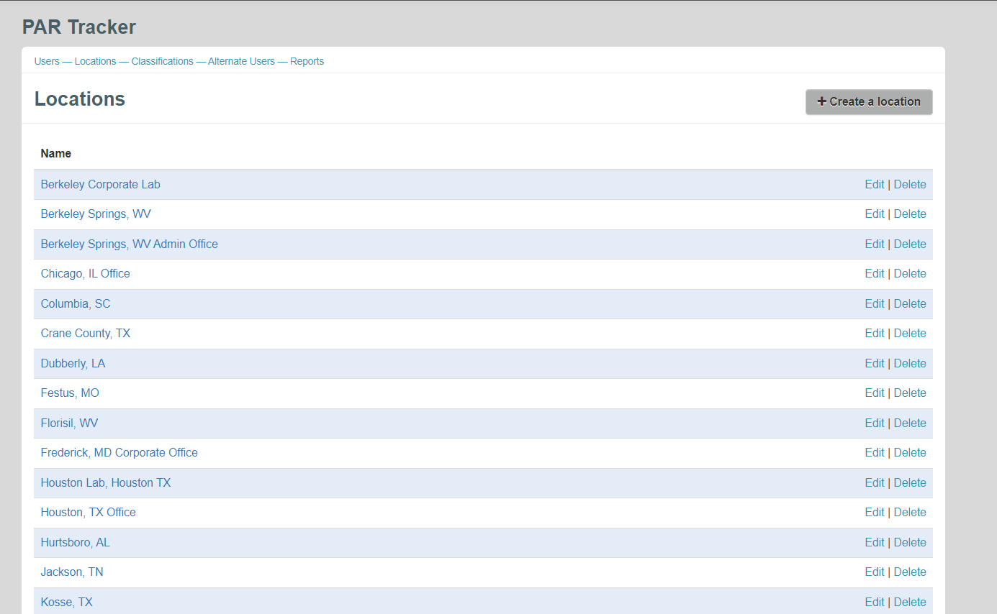

- Create a Location:
Enter the name and code of the location to be added and click create.
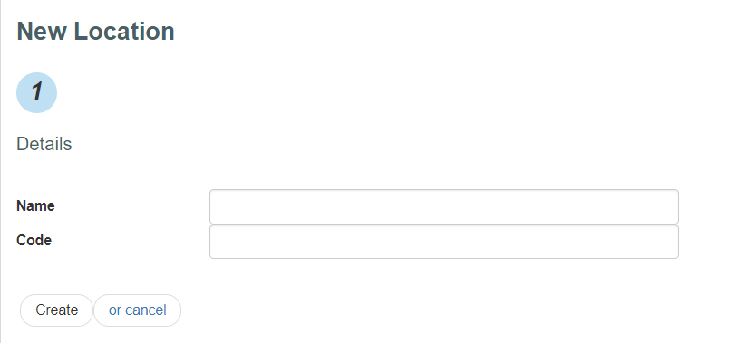
- Classification: Lists all the project classifications. Create or edit a classification.
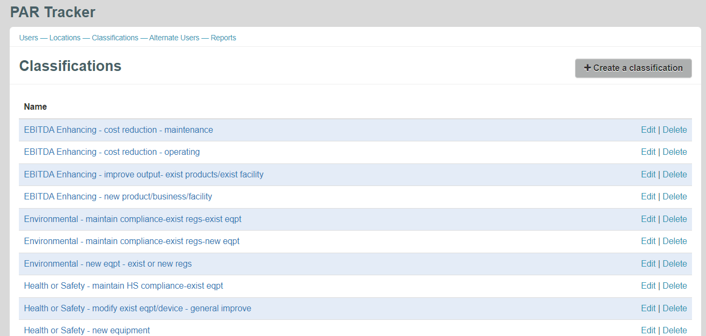

- Create a Classification:
Enter the name of the new classification to be created and click create.
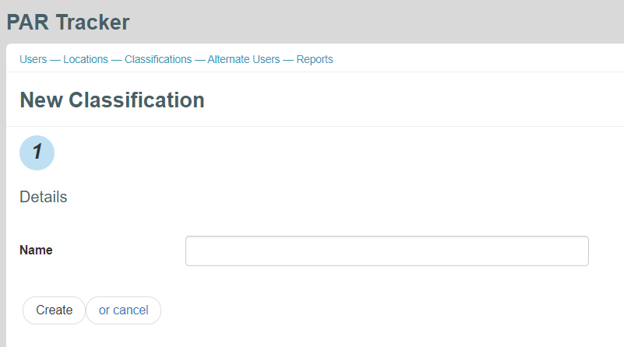

- Reports: Click on Time To Complete to generate a report of all the projects (excel). The report will be sent to the email of the user.
